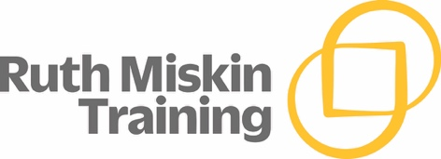
Year 1 Phonic Screening Check

What is the Phonics Screening Check?
Every Year 1 child in the country will be taking the statutory (set by the Government) Phonics Screening Check in the same week. The check is very similar to tasks the children already complete during Phonics lessons. The focus of the check is to provide evidence of children’s decoding and blending skills, not to test their vocabulary or reading level. In previous years the pass mark for attaining the expected standard has been 32 marks.

How is the check administered?
The Phonics Screening Check is carried out in a 1:1 situation with your child’s class teacher. Each check should take about 5 minutes. The children will read 40 words – a combination of real words and nonsense ‘alien’ words. Children will be told if the word they are reading is a real or ‘alien’ word by a picture of an alien at the side of the word.

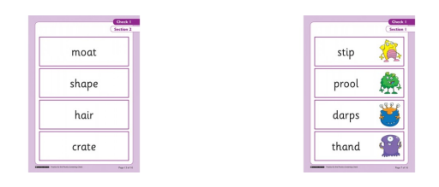

When will the check take place?
All Phonics Screening Checks will take place during the week beginning: Monday 8th June 2026.
If your child doesn’t meet the required standard, they will re-take the check in year 2.

What can you do to help at home?

- Use ‘Special Friends’, ‘Fred Talk’, read the word, to read words.
- Practise reading sounds speedily - ‘review, review, review’.
- Listen to your child read their Read Write Inc. Storybook every day.

There are free video tutorials on the Ruth Miskin website – www.ruthmiskin.com
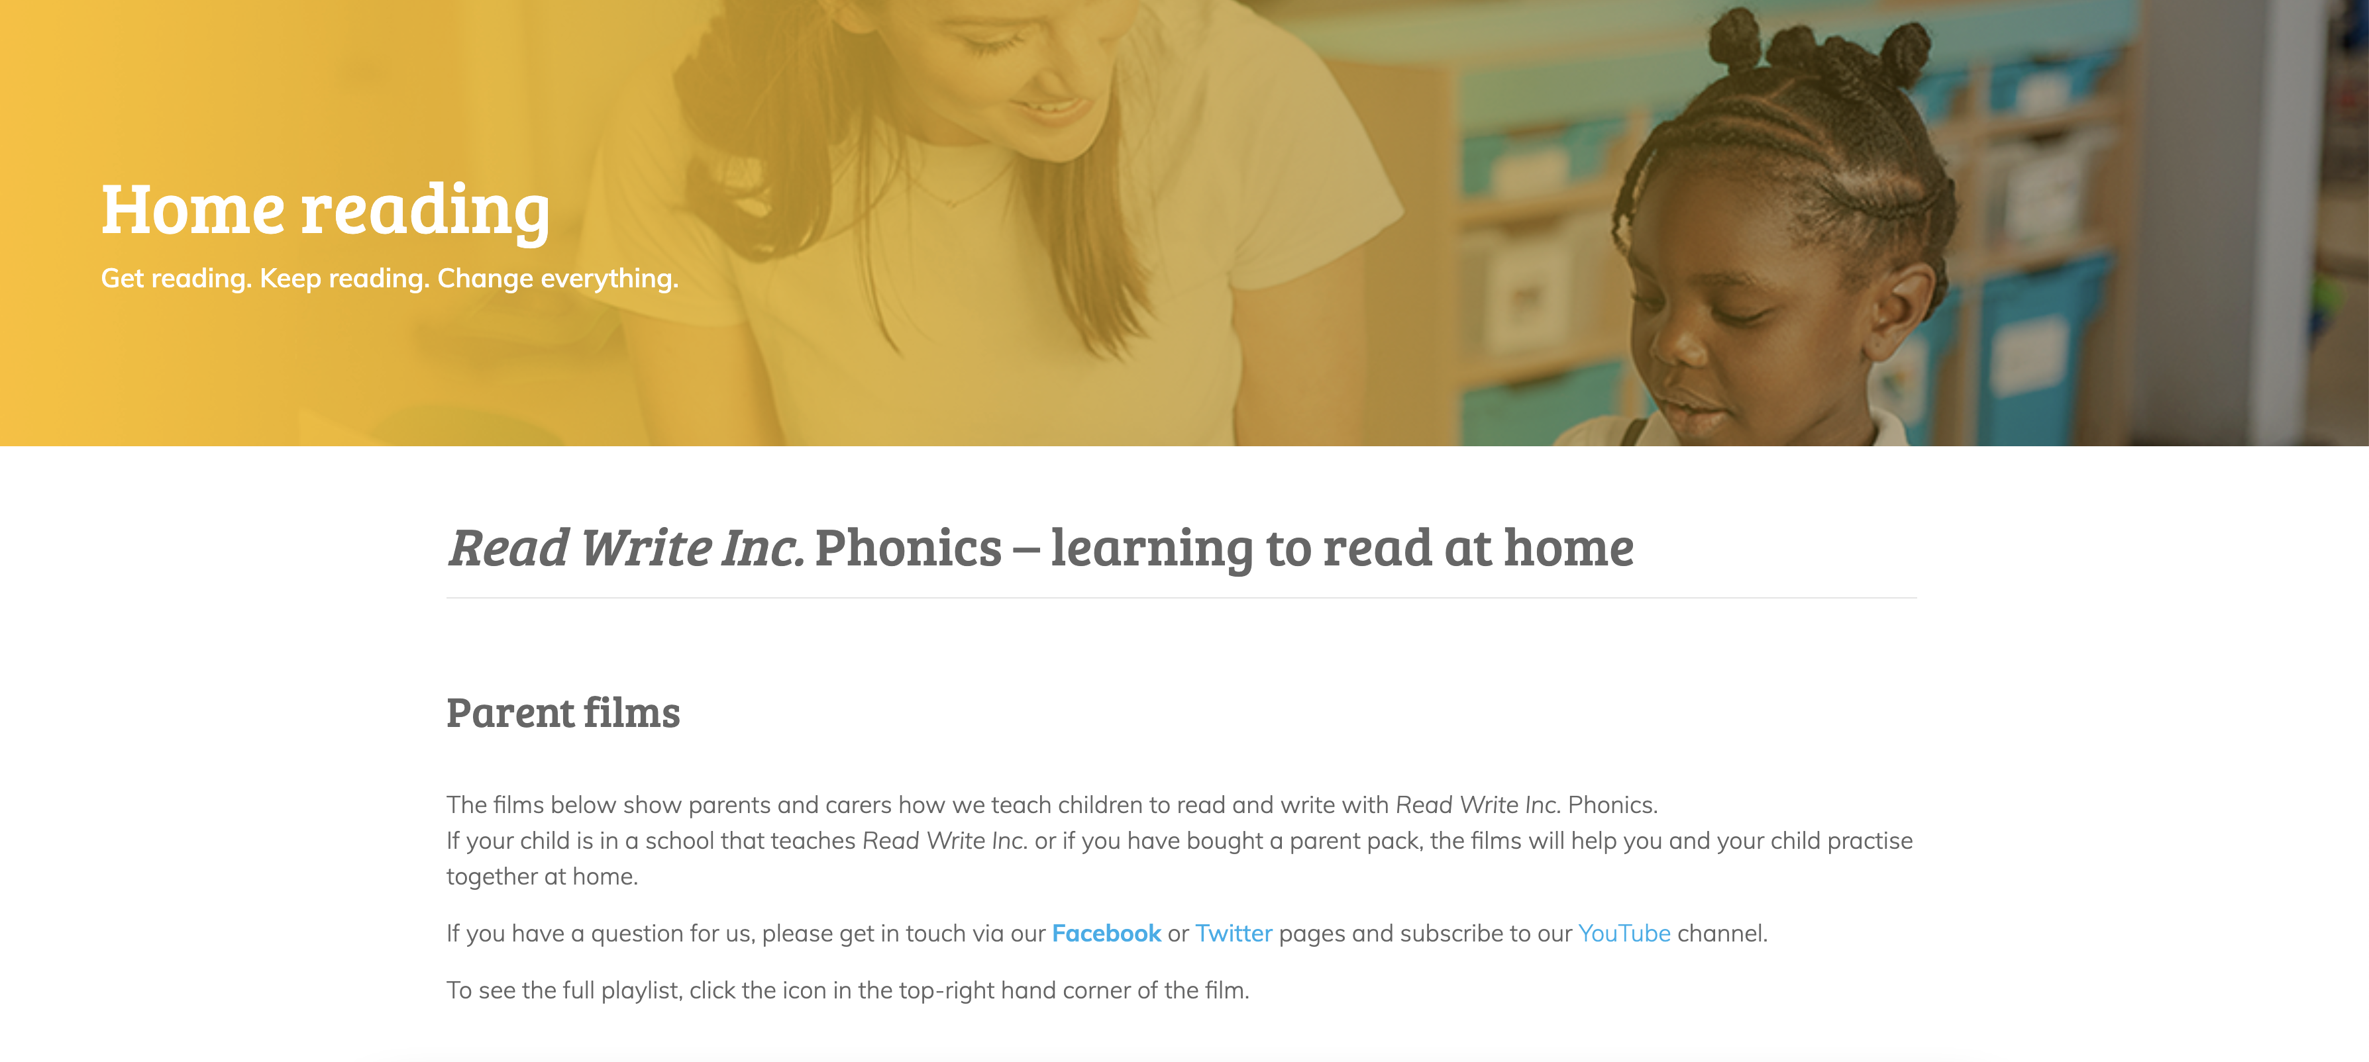

Free e-books for home reading:http://www.oxfordowl.co.uk/Reading/

