Art & Design Overview
EYFS Framework – Expressive Art & Design
The development of children’s artistic and cultural awareness supports their imagination and creativity. It is important that children have regular opportunities to engage with the arts, enabling them to explore and play with a wide range of media and materials. The quality and variety of what children see, hear and participate in is crucial for developing their understanding, self-expression, vocabulary and ability to communicate through the arts. The frequency, repetition and depth of their experiences are fundamental to their progress in interpreting and appreciating what they hear, respond to and observe.
Understanding the World Early Learning Goal: Creating with Materials & Fine Motor Skills
The level of development children should be expected to have attained by the end of the EYFS is defined by the early learning goals (ELGs) as set out below. 1.8 The ELGs should not be used as a curriculum or in any way to limit the wide variety of rich experiences that are crucial to child development, from being read to frequently to playing with friends.
1.9 Instead, the ELGs should support teachers8 to make a holistic, best-fit judgement about a child’s development, and their readiness for year 1.
1.10 When forming a judgement about whether an individual child is at the expected level of development, teachers should draw on their knowledge of the child and their own expert professional judgement. This is sufficient evidence to assess a child’s individual level of development in relation to each of the ELGs. Sources of written or photographic evidence are not required, and teachers are not required to record evidence.
Children at the expected level of development for Creating with Materials will:
- Safely use and explore a variety of materials, tools and techniques, experimenting with colour, design, texture, form and function;
- Share their creations, explaining the process they have used;
Children at the expected level of development for Fine Motor Skills (within Physical Development) will:
- Use a range of small tools, including scissors, paint brushes and cutlery;
- Begin to show accuracy and care when drawing.
Focus across EYFS at St. Christopher’s
Nursery Autumn 1 – Exploring Colour
Nursery Autumn 2 – Shape & Lines
Nursery Summer 1 – Exploring & Joining Materials
Reception Autumn 1 – Artistic Effects
Reception Spring 2 – Being Creative

 | Autumn Term | Spring Term | Summer Term
Year 1 | Developing a sketchbook – continuous across the year  - begin to demonstrate their ideas through photographs and in their sketch books  - set out their ideas, using ‘annotation’ when able in their sketch books
Year 1 | DRAWING  Theme – All about me  Artist – Pablo Picasso  Spanish 1881 – 1973 Cubism  Medium – Pencil & crayon  - communicate something about themselves in their drawing  - create moods in their drawings  - draw using pencil and crayons  - draw lines of different shapes and thickness, using 2 different grades of pencil  Key Vocabulary – drawing, pencil, crayon, mood, colour, line - thick, thin, shape, grade  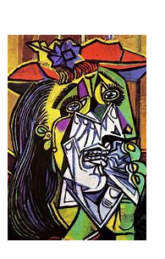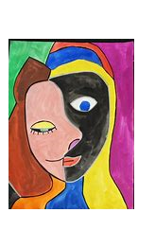  3D  Theme – Magical Trees  Artist – Gustav Klimt  1862 – 1918 Austrian – Art Nouveau/Symbolism  Medium – Various materials.  - add texture by using tools  - make different kinds of shapes  - cut, roll and coil materials such as clay, dough or plasticine  Key Vocabulary – materials, tools, clay, dough, roll, cut, coil, shape  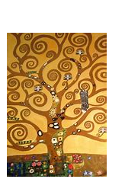 | PAINTING  Theme – Circles  Artist -Wassily Kandinsky  1866 – 1944 Russian - Expressionism, Bauhaus  Medium – Block paints  - communicate something about themselves in their painting  - create moods in their paintings  - choose to use thick and thin brushes as appropriate  - paint a picture of something they can see  - name the primary and secondary colours  Key Vocabulary – paint, primary colours, secondary colours, brush, thick, thin, mix  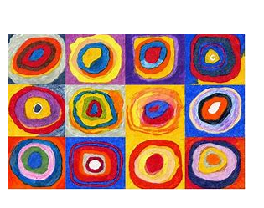  PRINTING  Theme – In the Kitchen  Artist – N/A  Medium – Natural & man-made materials from the kitchen.  - print with sponges, kitchen utensils, vegetables and fruit  - print onto paper and textile  - design their own printing block  - create a repeating pattern  Key Vocabulary – print, repeat, pattern, sponge, vegetables, fruit, printing block  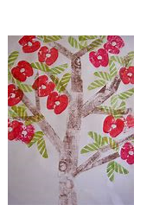 | COLLAGE  Theme – Found Objects  Artist – N/A – children can use various images/prepared examples to create a found objects collage in a shoe box lid – focused on a colour.  Medium – found objects  - cut and tear paper and card for their collages  - gather and sort the materials they will need  Key Vocabulary – collage, cut, tear, paper, card, gather, sort, materials  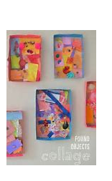

 | Autumn Term | Spring Term | Summer Term
Year 2 | Developing a sketchbook – continuous across the year  - begin to demonstrate their ideas through photographs and in their sketch books  - set out their ideas, using ‘annotation’ in their sketch books  - keep notes in their sketch books as to how they have changed their work
Year 2 | DRAWING  Theme – Buildings  Artist – L.S. Lowry  1887 – 1976 English artist  Medium – Pencil and charcoal  - use three different grades of pencil in their drawing (4B, 8B, HB)  - use charcoal, pencil and pastels  - create different tones using light and dark  - show patterns and texture in their drawings  - use a viewfinder to focus on a specific part of an artefact before drawing it  Key Vocabulary – draw, pencil, charcoal, tone, light, dark, grade, pattern, texture, viewfinder, line, thick, thin  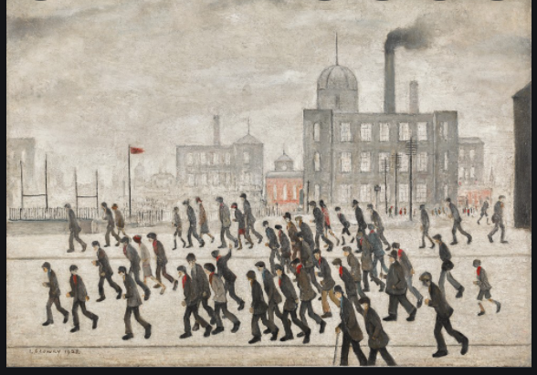  PAINTING  Theme – Flowers & Plants  Artist – Georgia O’Keeffe  1887 – 1986 American Modernist  Medium – poster paints  - mix paint to create all the secondary colours  - mix and match colours, predict outcomes  - mix their own brown  - make tints by adding white  - make tones by adding black  Key Vocabulary – paint, mix, primary colours, secondary colours, tints, tones, predict  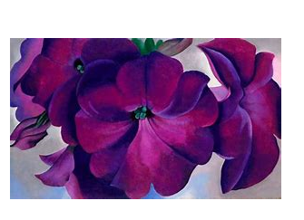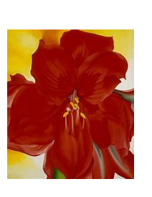 | 3D  Theme – Human Form  Artist – Antony Gormley (The Field 1991)  1950 – present English sculpure  Medium - Clay  - Explore qualities of materials  - Manipulate materials  - Explore and create texture.  Key Vocabulary – 2D to 3D, clay, manipulate, shape, form, texture  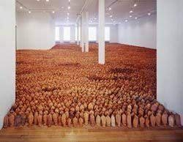  PRINTING  Theme – Flowers & Plants  Artist – William Morris  1834 – 1896 English – British Arts & crafts.  Medium – natural & man-made materials.  - create a print using pressing, rolling, rubbing and stamping  - create a print like a designer  Key Vocabulary – print, press, roll, rub, stamp, designer, pattern, natural, man-made.  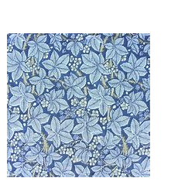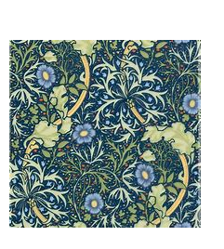 | COLLAGE  Theme – Weaving – The Great Fire of London  Artist – N/A – using a range of artists work to create individual and then a group piece.  Medium – various materials, including fabrics and ribbon.  - create individual and group collages  - use different kinds of materials on their collage and explain why they have chosen them  - use repeated patterns in their collage  Key Vocabulary – collage, create, pattern, repeated pattern, texture, colour, choice  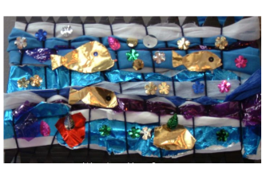

 | Autumn Term | Spring Term | Summer Term
Year 3 | Developing a Sketchbook – continuous over the year  - use their sketch books to express feelings about a subject and to describe likes and dislikes  - make notes in their sketch books about techniques used by artists  - suggest improvements to their work by keeping notes in their sketch books
Year 3 | DRAWING  Theme – Faces – Eyes  Artist – Sandra Silberzweig  1960 – present Canadian artist  Medium – pencil, oil and chalk pastels  - show facial expressions in their drawings  - use their sketches to produce a final piece of work  - write an explanation of their sketch in notes  - -use different grades of pencil shade, to show different tones and texture  Key Vocabulary – draw, pencil, oil pastels, chalk pastels, sketch, grade, shade, tones, texture  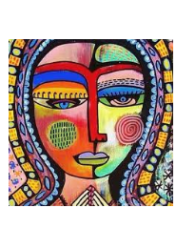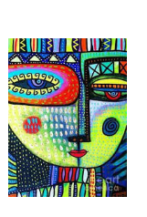  PAINTING  Theme – Feelings  Artist – Jackson Pollock  1912 – 1956 American – Abstract Expressionism and Surrealism  Medium – poster paints  - predict with accuracy the colours that they mix  - know where each of the primary and secondary colours sits on the colour wheel  - create a background using a wash  - use a range of brushes to create different effects  Key Vocabulary – paint, feelings, mood, mix, primary and secondary colours, background, wash, effects, tools, colour wheel  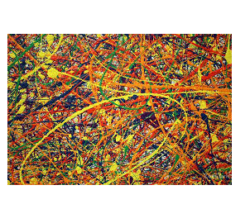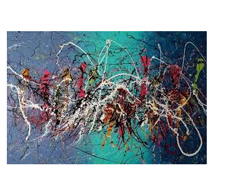 | PRINTING  Theme – Pop Art – Comic Books  Artist – Roy Fox Litchenstein  1923 – 1997 American Pop Artist  Medium - polystyrene, card, bubble wrap.  - make a printing block  - make a 2 colour print  Key Vocabulary – printing block, primary colour, secondary colour, printing ink, polystyrene, Pop art  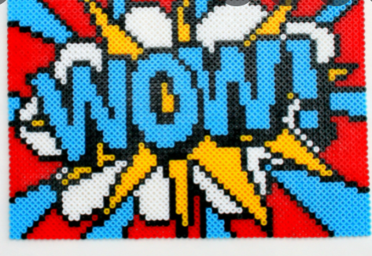  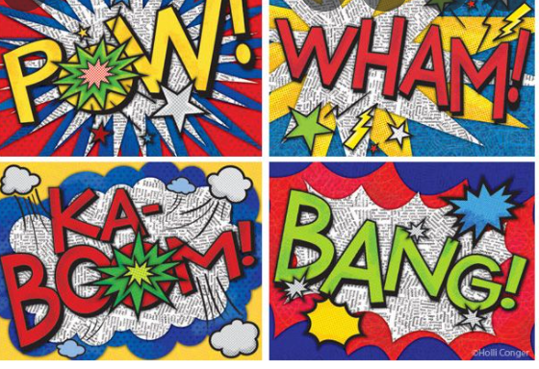  COLLAGE  Theme – Ceramic Mosaic Ceramic  Artist – (variety of artists including Roman art, Ed Chapman and Antoni Gaudi)  Medium – Ceramic pieces.  - begin to create more detailed pieces.  - combine visual and tactile qualities  - experiment using different colours  Key Vocabulary – collage, visual, tactile, combine, detail, mosaic, shape, colour  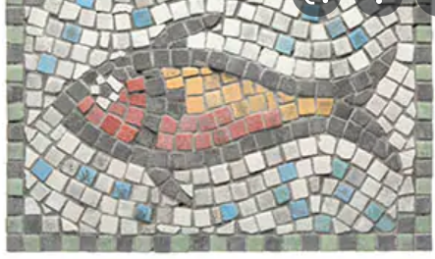  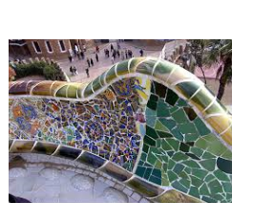 | 3D  Theme – Movement & Explosion  Artist – Frank Stella  1936 – present American – Abstract expressionism  Medium – Card and paper  - add onto their work to create texture and shape  - work with cardboard and paper to create a variety of textures and shapes  - create pop-ups  Key Vocabulary – 3D, card, paper, texture, shape, pop-up, materials  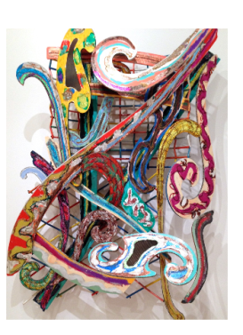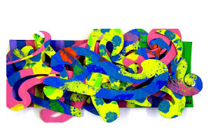

 | Autumn Term | Spring Term | Summer Term
Year 4 | Developing a sketchbook – continuous across the year  - Use their sketchbooks to express their feelings about various subjects and outline likes and dislikes  - Produce a montage all about themselves  - Use their sketchbook to adapt and improve their original ideas  - Keep notes about the purpose of their work in their sketchbooks
Year 4 | PAINTING  Theme – Landscapes in Watercolour  Artist – Claude Monet  1840 – 1926 French Painter  Medium – Watercolour paints  - create all the colours they need  - create mood in their paintings  - successfully use shading and blending to create mood and feeling  - create a watercolour wash as a base for their artwork.  Key Vocabulary -paint, watercolour, wash, base, effect, shading, blending, colour, mood  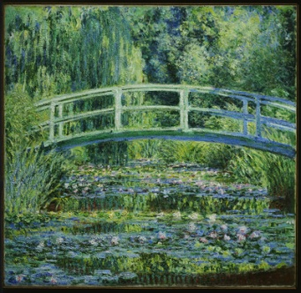  PRINTING  Theme – Animal Patterns  Artist – Various Artists  Medium – fabric printing creating own printing blocks.  - print using at least four colours  - create an accurate print design  - print onto different materials  - create own printing block  Key Vocabulary – print, pattern, accuracy, design, material, printing block  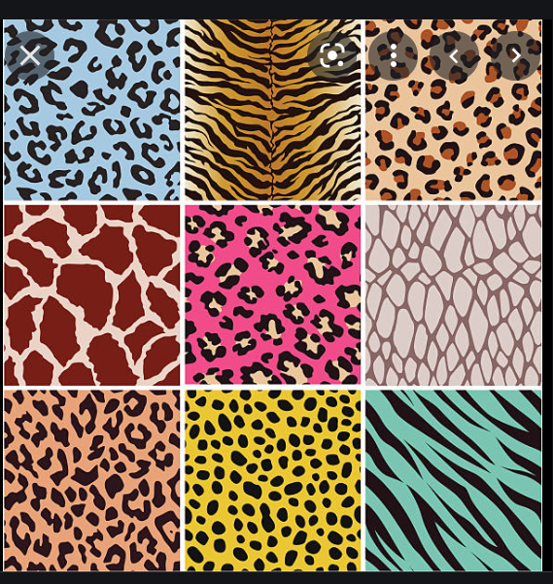 | 3D  Theme – Cacti – papier mache  Artist – Kim Sielbeck  American  Medium – mod-roc, card, paper, papier mache  - experiment with and combine materials and processes to design and make 3D form  - begin to sculpt mouldable materials  - use various materials to create texture and shape.  Key Vocabulary – 3D, sculpture, mould, mod-roc, Medium – mod-roc, card, paper, papier mache  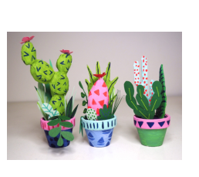  DRAWING  Theme – Architecture  Artist – Alfred Waterhouse  Medium - Pencil, pen and charcoal  - identify and draw simple objects, and use marks and lines to produce texture  - successfully use shading to create mood and feeling  - organise line, tone, shape and colour.  - show reflections  - explain why they have chosen specific materials to draw with  Key Vocabulary – drawing, architecture, line, texture, tone, shape, colour, reflections, materials  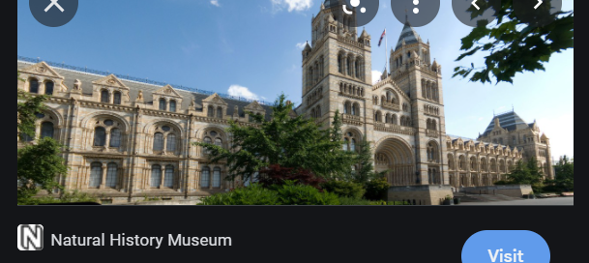  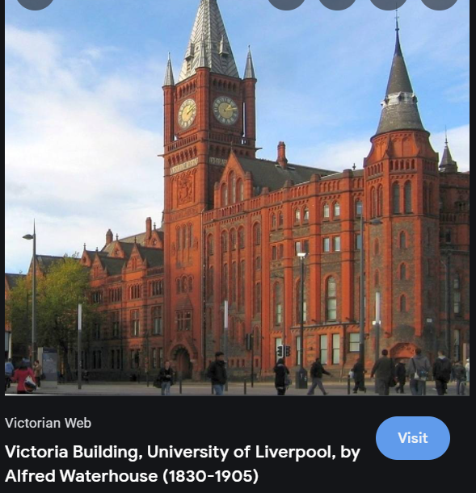 | COLLAGE  Theme – Birds  Artist – Various Artists  Medium – papers, card, tissue, fabric  - overlap materials  - begin to create more detailed pieces.  - combine visual and tactile qualities  - cut very accurately  - overlap materials  Key Vocabulary – collage, paper, card, tissue, fabric, overlap, visual, tactile, accuracy, materials,  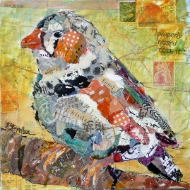  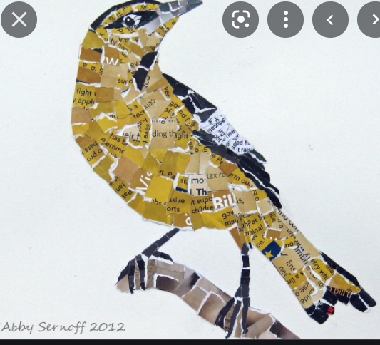

 | Autumn Term | Spring Term | Summer Term
Year 5 | Developing a sketchbook – continuous over the year  - keep notes in their sketch books as to how they might develop their work further  - use their sketch books to compare and discuss ideas with others
Year 5 | DRAWING & PHOTOGRAPHY  Theme – Movement  Artist – Edgar Degas and various other artists.  1834 – 1917 French Impressionist Artist  Medium – various for pupils to choose from.  - Begin to show body language in their sketches  - Identify and draw simple objects, and use marks and lines to produce texture  - Organise line, tone, shape and colour to represent figures and forms in movement  - Explain why they have chosen specific materials to draw with.  - Take photographs to support their drawings  Key Vocabulary – drawing, sketch, movement, impression, body language, line, shade, tone, shape, colour, foreground, middle ground, background.  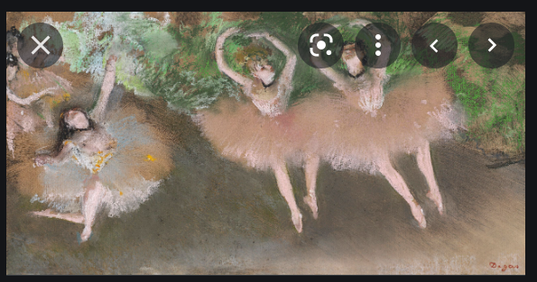  3D  Theme – People  Artists – Alberto Giacometti & Anthony Gormley  Giacometti -1901 – 1966 Swiss – Surrealism/Cubism  Gormley - 1950 – present – British sculptor  Medium – Wire, foil, mod-roc, clay  - experiment with and combine materials and processes to design and make 3D form  - sculpt clay, wire and other mouldable materials  Key Vocabulary – 3D, sculpture, materials, combine, shape, form, line, mould  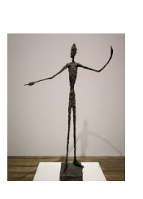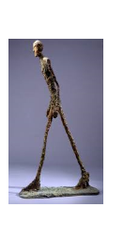 | PAINTING  Theme – The Sky  Artist – Vincent Van Gogh  1853 – 1890 Dutch – Post Impressionism/Neo Impressionism  Medium – Acrylic paint  - create a range of moods in their paintings  - create texture using acrylic paint.  - express their emotions accurately through their painting and sketches  Key Vocabulary – paint, acrylic, texture, tools, mood, background, foreground, sketch, materials.  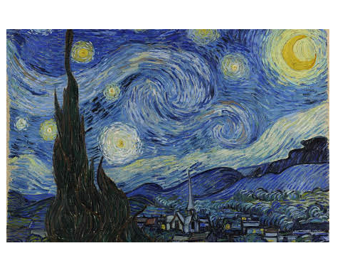  PRINTING  Theme – Rotation  Artist – N/A – Rotational square fabric prints.  Medium – Fabric printing.  - print using a number of colours  - create an accurate print design that meets a given criteria  - print onto different materials  Key Vocabulary – print, inks, rotation, design, materials  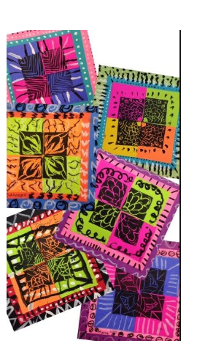 | COLLAGE  Themes – Landscapes Paper, card, tissue.  Artist – Various artists  - combine visual and tactile qualities to express mood and emotion?  - overlap materials  - begin to create more detailed pieces.  - cut very accurately  Key Vocabulary – collage, mood, emotion, overlap, accuracy, detail,  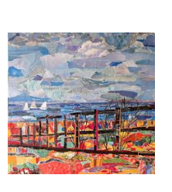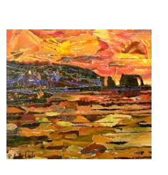

 | Autumn Term | Spring Term | Summer Term
Year 6 | Developing a sketchbook – continuous throughout the year  - sketch books contain detailed notes, and quotes explaining about items  - compare their methods to those of others and keep notes in their sketch books  - combine graphics and text based research of commercial design, for example magazines etc., to influence the layout of their sketch books.  - adapt and refine their work to reflect its meaning and purpose, keeping notes and annotations in their sketch books
Year 6 | PAINTING  Theme – Silhouettes  Artist/s – Marc Allante  1988 – Present Hong Kong  Medium – inks and watercolours  - explain what their own style is  - use a wide range of techniques in their work  - explain why they have chosen specific painting techniques  Key Vocabulary – paint, inks, watercolours, techniques, colour, effect, wash, own style  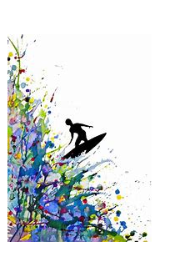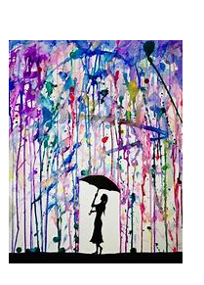  3D  Theme – Beauty is in the eye of the Beholder!  Artist – Henry Moore  1898 – 1986 English – Modernism  Medium - a range of materials including clay, mod-roc and plaster of paris.  - create models on a range of scales  - create work which is open to interpretation by the audience  - include both visual and tactile elements in their work  Key Vocabulary – 3D, Sculpture, scale, mould, visual, tactile, interpretation, audience  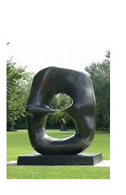  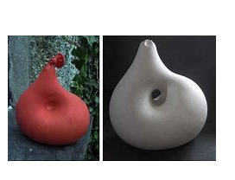 | DRAWING  Theme – Insects  Artists –Cath Hodsman  English natural history artist and illustrator.  Medium – various drawing materials to choose from.  - sketches communicate emotions and a sense of self with accuracy and imagination  - explain why they have combined different tools to create their drawings  - explain why they have chosen specific drawing techniques  Key Vocabulary – observation, draw, pencil, charcoal, pastels, grade, accuracy, sketch, techniques  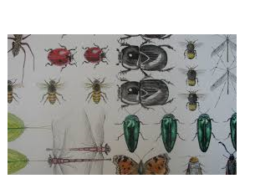  I-MEDIA AND GRAPHIC ART  Theme – Advertisements  Artist – Various  Materials – paper-based projects and computer based.  - overlay graphics and text for effect.  - use positioning and order to create mood and emotion.  - Use colour, shape, line and texture to create mood and emotion.  - Use computer-based programmes to create digital artwork.  Key Vocabulary – graphics, digital art, colour, shape, text, texture, images, mood, emotion,  PSHE Link – focus on body image – airbrushing and body shaming. | COLLAGE  Theme –Recycled Art  Artists – Various artists  Materials – recycled materials  - justify the materials they have chosen  - combine pattern, tone and shape  - work collaboratively to create large scale pieces of artwork.  Key Vocabulary – collage, recycle, materials, tone, pattern, shape, collaborate  

